The ApolloSM LSP offers a unique combination of two resource and patron sharing options: VersaCat® Discovery and VersaCard® Consortia.

VersaCat® Discovery lets your patrons search other libraries.

VersaCard is uniquely flexible in the consortia world. It allows Apollo libraries to loan to one another’s patrons with ease while still retaining their autonomy. Libraries can enter and exit the group at will. There is no charge for entry/exit and there is no impact on the fees of libraries in the group. It’s an ad hoc or bottom-up consortium approach. VersaCard does NOT combine library data; each library retains its own Apollo data and account and its own relationship with Biblionix. Billing and Apollo option choices remain in hands of each individual library. It’s the best of both worlds: the sharing capabilities of a consortium and the autonomy/lower complexity of stand-alone operation.

You can deploy only VersaCat only or you can use both VersaCat and VersaCard. There is a continuum of capability available; from discovery only, to honoring library cards from other libraries, to cross-library reserving and transporting.

VersaCat
To setup VersaCat
- for any Apollo library. Go to Setup | Catalog Sharing to select which libraries.
- for any non-Apollo library that shares their Z39.50 server information with you (IP address, port number, database name). When you get that information, send it to your representative so we can add it to your account.
From there, its use in the catalog is self-explanatory.

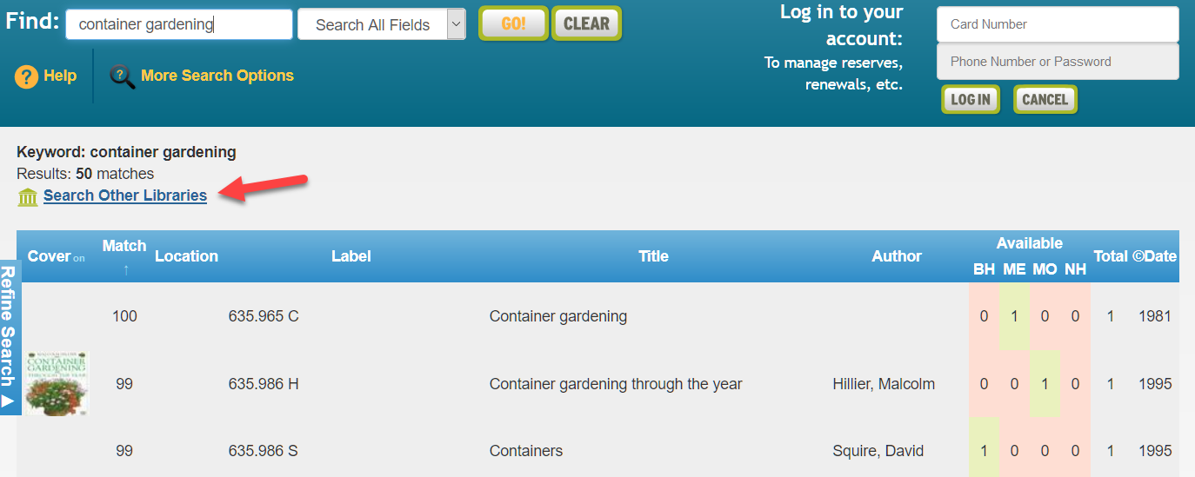

VersaCard

VersaCard can be added to VersaCat and allows Apollo libraries to participate in an ad hoc or bottom-up consortium. There are two primary components to VersaCard use:
- VersaCard Members: This allows a patron to physically go to other libraries in the group and use their home library card to checkout items. Example: A Library A patron can go into Library B and use their Library A card to checkout Library B items. This is a fundamental part of VersaCard. Special VersaCard circ rules can be applied. Generally speaking, VersaCard patrons from other libraries are treated as though they are your library's own patrons.
- VersaCard ILL: This is an optional part of VersaCard, allowing patrons to request items and have them delivered to their home library for checkout (just like an ILL). Example: In the library A catalog, a Library A patron places a reserve on a title that is owned by Library B. The item is transported to Library A where the patron checks it out (never having gone to Library B).

Other points:
- Patrons need only their home library card; not a “system” card or card from each library.
- Patron info is not shared with other libraries willy-nilly. Library A, for example, cannot see any information on patrons of other libraries unless the patron uses their home card at Library A (VersaCard Member). Once that scan has happened, the visiting patron’s account is linked to your library, and they can log into your public catalog, use self-checkout, borrow materials, log into your PC/time print management system, and more.
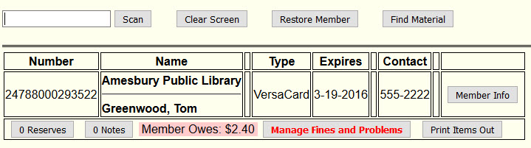
- When a VersaCard Member’s account is loaded in Checkout, their home library shows just above their name:

VersaCard Specifics

Member Information: Patron account information can only be updated by the home library, including via the public catalog.

Member and Material numbers: If all libraries in the group use Codabar/14-digit card number schemes (with a unique Codabar ID for each library), then patrons’ home cards can be used at any library with no issue. Same with materials at “other” libraries. If there are any libraries in your group that have short/non-Codabar/14-digit patron cards, a prefix will likely be needed for each, to be keyed-in prior to scanning cards/items from those libraries. Note that some libraries may have mixed Codabar and non-Codabar for materials and/or patrons (like if they are slowly transitioning to Codabar).
- That library can still participate in a VersaCard group and will need a prefix for the short numbers. The prefix is not required if a Codabar barcode label is involved.
- A prefix is only needed at libraries that do not own the item or by patrons visiting another library. A mixed-number library does not need to use a prefix on its own items/patrons.

Problems and Fines: Any block at any library will block the patron at all libraries. Blocks are determined policies set by the library that checked out the item to the patron; just like a typical ILL. Other libraries can see at which libraries a member has outstanding balances and can use that information to inform the patron of where they owe money. Payments can only be made at the library where charges were incurred.

Reports: In Reports, your library sees only the circulation information for items that it checks out.

Notifications: Notifications for overdues and reserves are sent by the library that checked out the item, not by the library that owns the item.

Databases and e-Resources: Databases on the main catalog page are available to VersaCard patrons through their home library as well as any library at which they have a VersaCard account. The exception to this is OverDrive. With OverDrive, a VersaCard patron is automatically connected to their home library account no matter where they log in. If you’d prefer to limit database access for VersaCard patrons, you can do so using the Permissions button in Setup | Databases/e-Resources.

VersaCard Individual Library Options (Limiting VersaCard Borrowing)

When a patron from Library A goes into Library B and checks out an item (VersaCard Member) that member is assigned to VersaCard types in Settings | Member Types and Settings | Member Types (Secondary). A VersaCard Member Type will be “VersaCard”, and Member Type (Secondary) will be “VersaCard - <libraryname>”. If you'd like to limit how you loan to visiting patrons, circulation rules can be set for these VersaCard types. NOTE: these are set individually by each library.

VersaCard Group Options

Share Patron Details (privacy option for VersaCard Members): This group option limits the amount of patron personal information that is exposed to the VersaCard library. When a member of Library A borrows an item from Library B, Library B can see some patron detail. This option limits how much. This option does not change the fact that blocking problems and blocking fines at any library will block the patron at all libraries.

Delete VersaCard Patron Link (privacy option for VersaCard Members): Your group can elect to delete member VersaCard links after all items have been returned and if there is no balance or blocking issue. The member’s record at her home library is unaffected. Only the link to that record from another library is removed. As an example: A member of Library A borrows an item of Library B’s. Due to that, Library B has visibility into Library A’s record of the member (the VersaCard member record). A fine accrues. The member returns the item and pays the fine. At that point, with this option enabled, Library B no longer has visibility into information about the Library A member; the VersaCard link to Library A is removed. NOTE: if you choose to enable this option, it might be dubious to enable the above “Member Search Across Libraries” option.

Member Search Across Libraries (privacy option for VersaCard Members): When you search for a member in Checkout, the results include VersaCard patrons by default. However, you can opt as a group to disable this.

Remote Checkin: If your group has transport capabilities, it can opt to allow checkin of items that belong to other libraries in the VersaCard group (this is part of the way along on the continuum of ‘cross library reserving’). In other words, Apollo would support the return of any library’s items at any library in the group. This option can be implemented without enabling VersaCard ILL (cross-library reserves). But if cross-library reserves is enabled, so is Remote Checkin.

When an item owned by Library A is checked in at Library B, it is removed from the patron account to which it was charged. At that point, the patron is off the hook. During the item’s trip back to Library A, the owning library, it will not be checked out to anyone. NOTE: when an in-transport item arrives at the owning library, it must be checked-in, like any other item being returned.
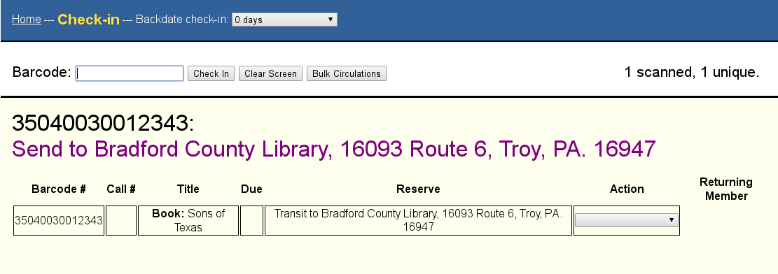
You will see where to send it in the Check-in screen. If you forget, just scan it again!

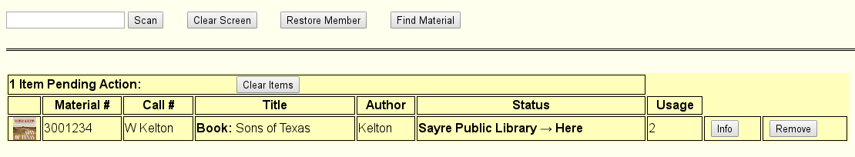
The owning library can see the status of their items on their way home.

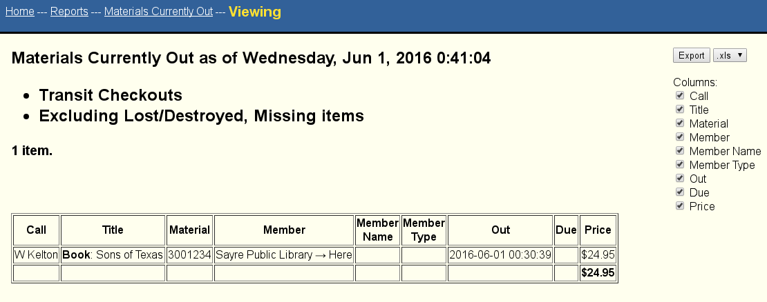
And the owning library can run the Materials Currently Out report to see all of their items that are in transit back home.

There is also a complete “Transit Log” to show all transit activity over the preceding 4 months.

Cross-library reserve/transport (VersaCard ILL option): This is the closest thing to being branches (while retaining autonomy!). If your VersaCard group is close-knit and you have transport capabilities, you can allow patron reserve requests to be filled by items from other libraries in the VersaCard group (via transport to the patron’s home library). As an example, a Library A patron’s reserve on a title could be filled by a copy owned by Library B, transported to Library A, and checked out to the requesting patron at Library A.

Also note that there are several ways each library can limit these type of reserves. Your group may decide that everyone should have the same settings.

- DELAY REQUEST BY YOUR PATRONS: For such requests/reserves by your patrons, you can delay when Apollo asks another library to fulfill/pull it. This is if your library owns a copy of a the desired item, but it is currently out. You can add X days of delay (days that the library is open). This can give staff some time to look into where the item is. (This is the “Delay in cross-library reserve placement, in days” option in the table below). Three days is a good place to start.

- PREVENT LOANING-- BY DATE ADDED: You can make recently added items ineligible to be sent to other libraries. See Settings | VersaCard ILL.

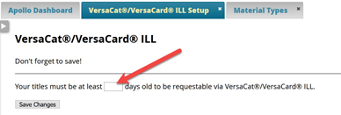

- PREVENT LOANING-- BY MATERIAL TYPE: You can make any material type ineligible to be sent to other libraries. See Settings | Material Types.

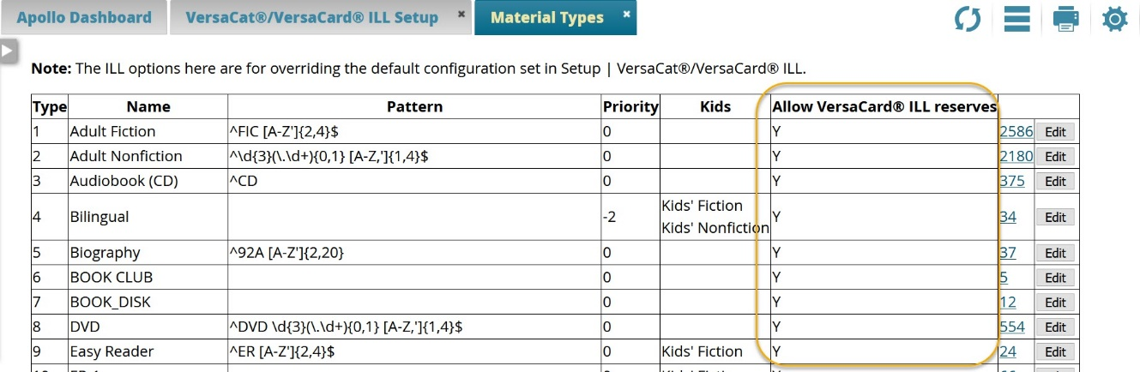

Getting VersaCard Setup for Your Group

While you can setup VersaCat, we need to help you setup VersaCard choices. See the two items below and contact your representative with the details. We’ll get your group setup and sharing!

1) Patrons with accounts at multiple libraries: Does your group have patrons who have cards at more than one library in the group? The ideal, of course, is to remove such accounts that are not at the patron’s ‘home’ library. Then VersaCard is free to do its magic. We have found that attempting to use a report of “possible matching” patrons across multiple libraries is impractical. There is too much variability. Other possibilities include one or more of:
- Run a “Member” report and sort by town or Zip to find candidate accounts. You can contact them. Or send us a List of member numbers so that we can add a note or a blocking problem. Your choice.
- Change your procedure for renewing accounts to evaluate if they are really “your” patron. If they are not, do not renew the card.
- At Checkout, you could also have staff look at the address of the patron by clicking the “Member Info” button.

2) Info and option choices: Please convey the info and choices below to your representative. Use this form or an email or phone call. Whatever is easiest for you.

OPTION | Group  Choices | Individual  Library Choice
What is the name of your VersaCard group/consortium?
Do all libraries use Codabar/14-digit member numbers with different Codabar IDs?
PRIVACY OPTIONS (VersaCard Members)
-Share Patron Details (Y/N)
-Delete VersaCard Patron link (Y/N)
-Search for Members Across Libraries (Y/N)
SHARING OPTIONS
-Remote Checkin (Y/N) (All VersaCard)
-Cross-Library Reserving / Transporting (Y/N) (VersaCard ILL)
-Delay in cross-library reserve placement, in days (1, 2, 3, etc.) (Settings | VersaCard ILL)
-“Newness” of item (Settings | VersaCard ILL)
-Limiting by Material Type (Settings | Material Types)

Frequently Asked Questions:

GENERAL
Q: Can other participating libraries override and renew items belonging to us?
A: No. Libraries can perform overrides for items that they own.

Q: How much can other libraries’ staff do for/to our patrons? Can they:
- Renew? A: They can renew their own items including overriding. They can renew your items up to the renewal limit.
- Reserve? A: Another library can place a reserve on one of its own items for one of your patrons. Only if the “cross-library reserve” option is enabled, can another library or its patrons place a reserve on one of your items.
- Override? A: Library A can override any block on a non-Library A patron, but only to checkout/renew Library A items.
- Update accounts? A: No.

Q: What’s the cost of VersaCat and VersaCard
A: There is no charge! And libraries can come and go at will; still no charge.

Q: Do other library’s settings supersede ours on things like circ history?
A: No. Although Library A can see what any patron has currently out at any library, regarding history, Library A can only see the history of what any patron did with Library A materials. Circ rule settings apply to items lent by that library. Note that you can have circ rules that apply only to VersaCard patrons.

Q: Can libraries with branches participate in a VersaCard consortium?
A: Yes!

Q: Can a library be in more than one VersaCard consortium? In other words, my library is in between two VersaCard consortium. Can we be in both?
A: Yes.

CROSS-LIBRARY RESERVES

Q: Is a cross-library reserve a biblio reserve? Based on ISBN?
A: Cross-library reserves are only biblio-level reserves. We match across libraries by ISBN or any other biblio-level number.

Q: How does Apollo pick which library to tell to fulfill a cross-library reserve? The first one who owns it who runs the Reserve Search List?
A: Well, kind of. Really, it's whichever library scans a copy of the item at Checkin first. That may or may not be a result of an appearance on the Reserve Search List. This is where the option "Delay in cross-library reserve placement," is really important. This lets the "home" library fill its own patron’s requests (if it can) before the reserve gets sent out to "the system". All libraries should want to set that to at least 1 day, maybe 3? Note that these are “open” days, when the library is not closed. BUT, we are changing this to a random approach, where one library, randomly chosen, will see such an item on the Reserve Search List.

Q: For such a reserve transported to another library for checkout, what circ rules apply?
A: For a checkout taking place at another library, the circ rules of that other library are used. The parameters that are considered are
1) Member Type: VersaCard
2) Member Type Secondary: VersaCard for a particular library in the consortium.
3) "Is a Temporary Title (on-the-fly / ILL)"
Q: Are all reserves VersaCard reserves? In other words, are they system wide?
A: Yes, but only for biblio reserves. The above X-day delay option has the effect of making the reserve a “local” reserve for X days. (Note that a library can still create a holding-level reserve in Edit Records for its own items and patrons)

Q: For VersaCard cross-library reserve for an item that is on the shelf, where does the “there’s an item on the shelf with a reserve” auto-email go?
A: The auto-email is only ever sent to the library whose catalog was used to place the reserve, ie, where the item is shelved.

Q: Can a patron from Library A log into the Library B catalog and place a reserve, etc?
A: Once a patron has presented his/her home library card at another library in the group, s/he will have the same functionality available to a patron of that other library (that’s a VersaCard Member). So in that case, the answer is yes. But remember that the capabilities available to VersaCard Members are limited by the Circulation Rules. So for example, if the rules allow, the Library A patron logged into the Library B catalog can place a reserve on a Library B item to be picked up at Library B, ie, there’s no transport functionality (it’s not a cross-library reserve). But if such a reserve is placed through the Library A catalog, in other words a cross-library reserve, then it would be transported to Library A.

